**WEB APPLICATION FOR RENTAL SERVICES**

**OF AGRICULTURAL TOOLS**

**Fiza Javeed1, Varun Chandrappa2, Rohit B M3, Ritika Panchal4, Md Zia Ur Rahman5**

**1**Student, School of CSE, Presidency University, Bangalore, Karnataka, India

**2**Student, School of CSE, Presidency University, Bangalore, Karnataka, India

**3**Student, School of CSE, Presidency University, Bangalore, Karnataka, India

**4**Student, School of CSE, Presidency University, Bangalore, Karnataka, India

**5**Assistant Professor, School of CSE&IS, Presidency University, Bangalore, Karnataka, India

[1FIZA.20201CSE0633@presidencyuniversity.in](mailto:1FIZA.20201CSE0633@presidencyuniversity.in), [2VARUN.20201CSE0602@presidencyuniversity.in](mailto:2VARUN.20201CSE0602@presidencyuniversity.in), [3ROHIT.20201CSE0627@presidencyuniversity.in](mailto:3ROHIT.20201CSE0627@presidencyuniversity.in), [4RITIKA.20201CSE0617@presidencyuniversity.in](mailto:4RITIKA.20201CSE0617@presidencyuniversity.in) ,

[5](mailto:5mdziaurrahman@presidencyuniversity.in)[mdziaurrahman@presidencyuniversity.in](mailto:5mdziaurrahman@presidencyuniversity.in)

------------------------------------------------------------***----------------------------------------------------------

***Abstract -*** *The "Web Application for Rental Services of Agricultural Tools" is a user-friendly platform facilitating efficient and transparent interactions between farmers and tool owners. With a comprehensive catalog featuring diverse agricultural tools, the application streamlines the rental process, allowing farmers to easily access the equipment they need. Key features include secure user authentication, an intuitive booking system with integrated payment gateways, and a robust review system for accountability. Geolocation services ensure convenient tool pickup and return, while analytics tools enable tool owners to optimize their inventory. By fostering collaboration and resource-sharing, this web application contributes to improved agricultural practices, cost-effective utilization of equipment, and economic sustainability within the farming community.*

**1. INTRODUCTION**

A web application that the farmers can use to hire tractors as well as other mechanizations at a nominal amount all using their mobile phones. This would not only help them avoid manual labor but can be also be considered as an important step to encourage this profession. By promoting efficient tool utilization, transparent transactions, and community collaboration, the project seeks to enhance productivity, reduce costs, and contribute to the sustainable development of agriculture. Through innovative features like secure authentication, a comprehensive tool catalog, and integrated payment solutions, the application aims to empower farmers and tool owners alike.

**2. LITERATURE REVIEW**

In the past, farmers seeking equipment would visit hardware stores, where a variety of farming tools and machinery were available. The convenience of having all necessary equipment in one place came at a higher cost for each item. Unfortunately, not every farmer had the financial means to acquire all the essential tools required for their farming activities.

**2.1 Disadvantages**

* It can be exhausting and time-consuming.
* Sometimes it takes more time.

**3. PROPOSED SYSTEM**

This web-based rental system for form equipment was extremely user-friendly. This website contains complete and up-to-date equipment data. Users can access the website by entering their username and password. Users can access this website at any time. We are primarily designing this article for disadvantaged farmers. They are unable to purchase all types of equipment as a result of this. As a result, we are attempting to provide a low-cost rental service.

**3.1 Front-End Development**

HTML and CSS were used to create the front page. The language used to create application web pages is called hypertext tagging language. The page is a static HTML document that is stored on a web server. Cascading Style Sheets were used to accomplish this (CSS). CSS is a style sheet language that describes a document's appearance and format. Class files are related to these CSS files. On web pages, we're employing DJANGO FRAMEWORK for this project.

**3.2 Back-End Development**

In implementing the retrospective procedure outlined in this paper, we leverage PYTHON technology. Our use of Python involves executing various operations based on logical constructs. Supporting the back-end functionality is a Database Management System (DBMS). This software empowers administrators to create, modify, delete, and update tables, essential components of a website.

Tables within the database can store diverse types of data, including numerical values, variable characters, and more. For our application, we have opted for SQL SERVER as the database management system to host the site. The selection of SQL SERVER is motivated by the fact that its development project has released its source code under the General Public License (GNU), rendering it an open-source web application. This choice aligns with the principles of open-source development and contributes to the accessibility and flexibility of our project.

**3.3 Database Design**

Designing a website stands out as a crucial and challenging endeavor. Upon registration by a seller or farmer, the provided information is securely stored on the site. The website functions as a repository for products, encompassing copyright details, descriptions, and accompanying images. Moreover, any goods that undergo administrative review are promptly updated on the website. This interconnection underscores the inherent linkage between the system and the website, emphasizing the integral role the website plays in managing and presenting information related to sellers, farmers, and their respective products.

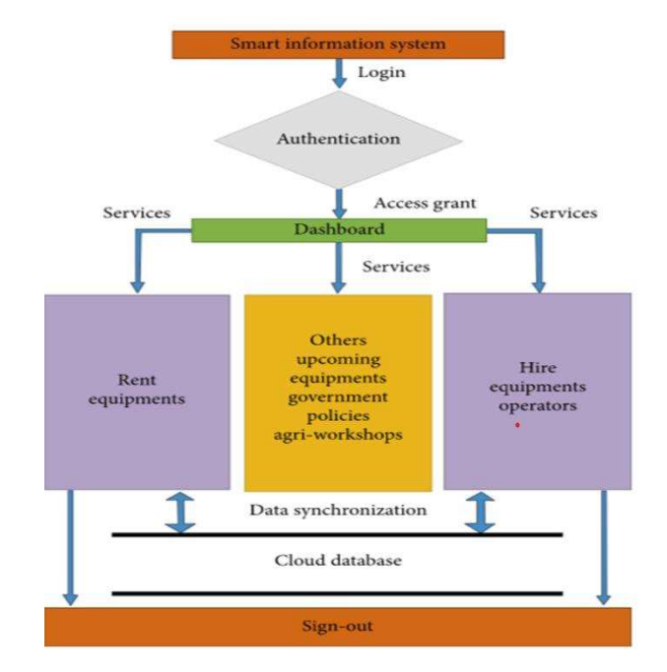

**3.4 Advantages**

* Use anywhere
* Low cost rent basis

**4. Modules**

This system has been specifically crafted to assist administrators and individuals involved in marriage ceremonies who seek a streamlined process for registering and obtaining marriage certificates efficiently. The application encompasses the following modules:

* Admin Module
* User Module
* Equipment Details Module

These modules collectively contribute to the seamless functioning of the application, catering to the distinct needs of administrators, users, and the meticulous handling of equipment details. The goal is to provide a comprehensive and user-friendly platform for efficient registration and certification of marriages.

**4.1 Admin**

* Admin login with the valid username and password.
* After that he can add and view Categories, Products, Service Providers. When adding Service Providers, the administrator must specify their location.
* Admin can also have the access to view the feedback from the user about the service provider and he can also block him.

**4.2 User**

* The user must be registered and login with their Email and Password.
* After logging, the user will select the Category and Service and send a query to the Service Provider.
* After the query is sent, the user will wait for the service provider solution and if he satisfies that is okay if not he can give feedback to admin

**4.3 Equipment details**

In every professional domain, the significance of equipment is paramount, and the agricultural sector is no exception. Recognizing the pivotal role that equipment plays in agriculture, we are committed to offering a diverse range of equipment at affordable rental prices. This initiative aims to support economically challenged farmers by providing them access to essential tools crucial for their agricultural activities.

**5. SCREENSHOTS**

After executing the above proposed system, we got the following results.

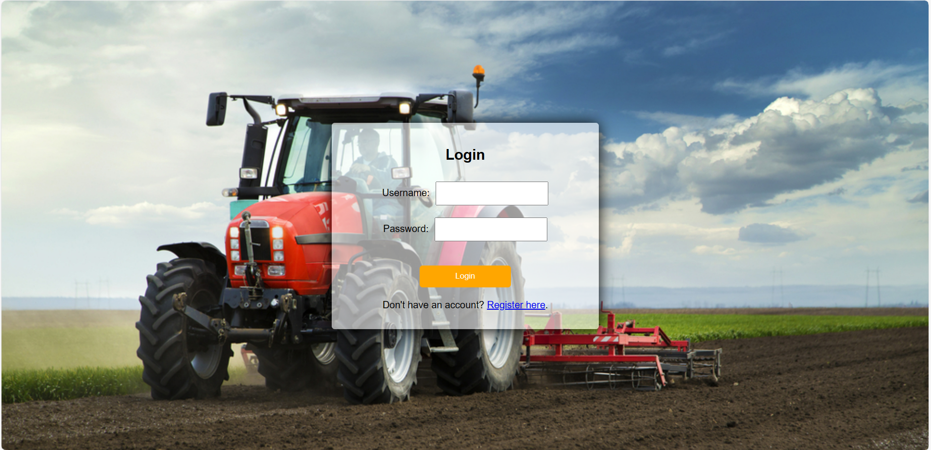

**Fig 5.1** Login Page

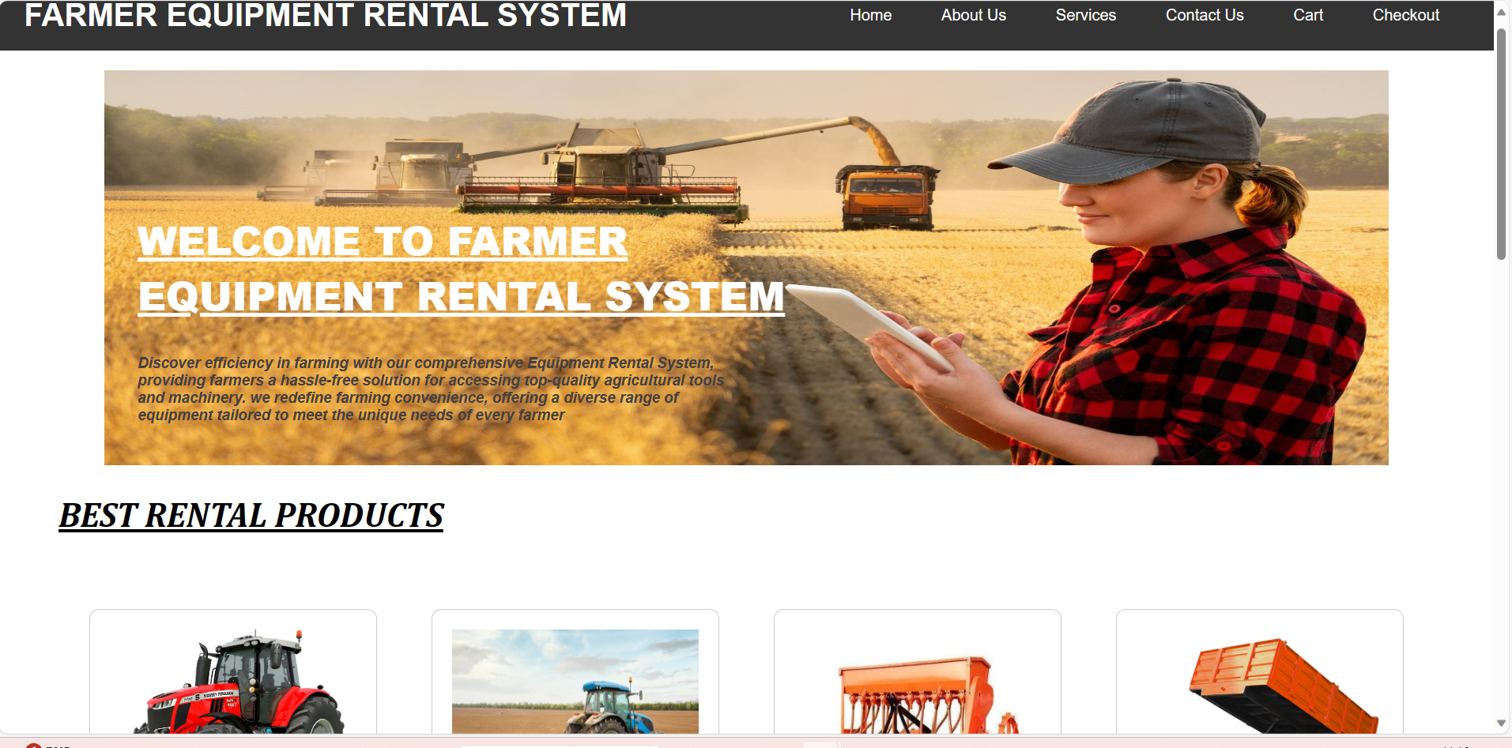

**Fig 5.2** Home Page

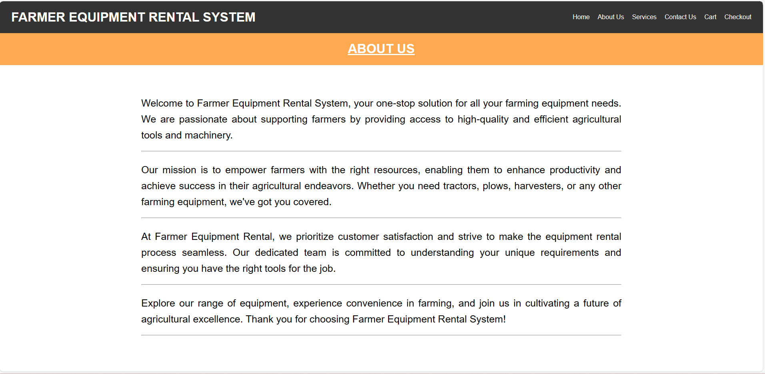

**Fig 5.3** About Page

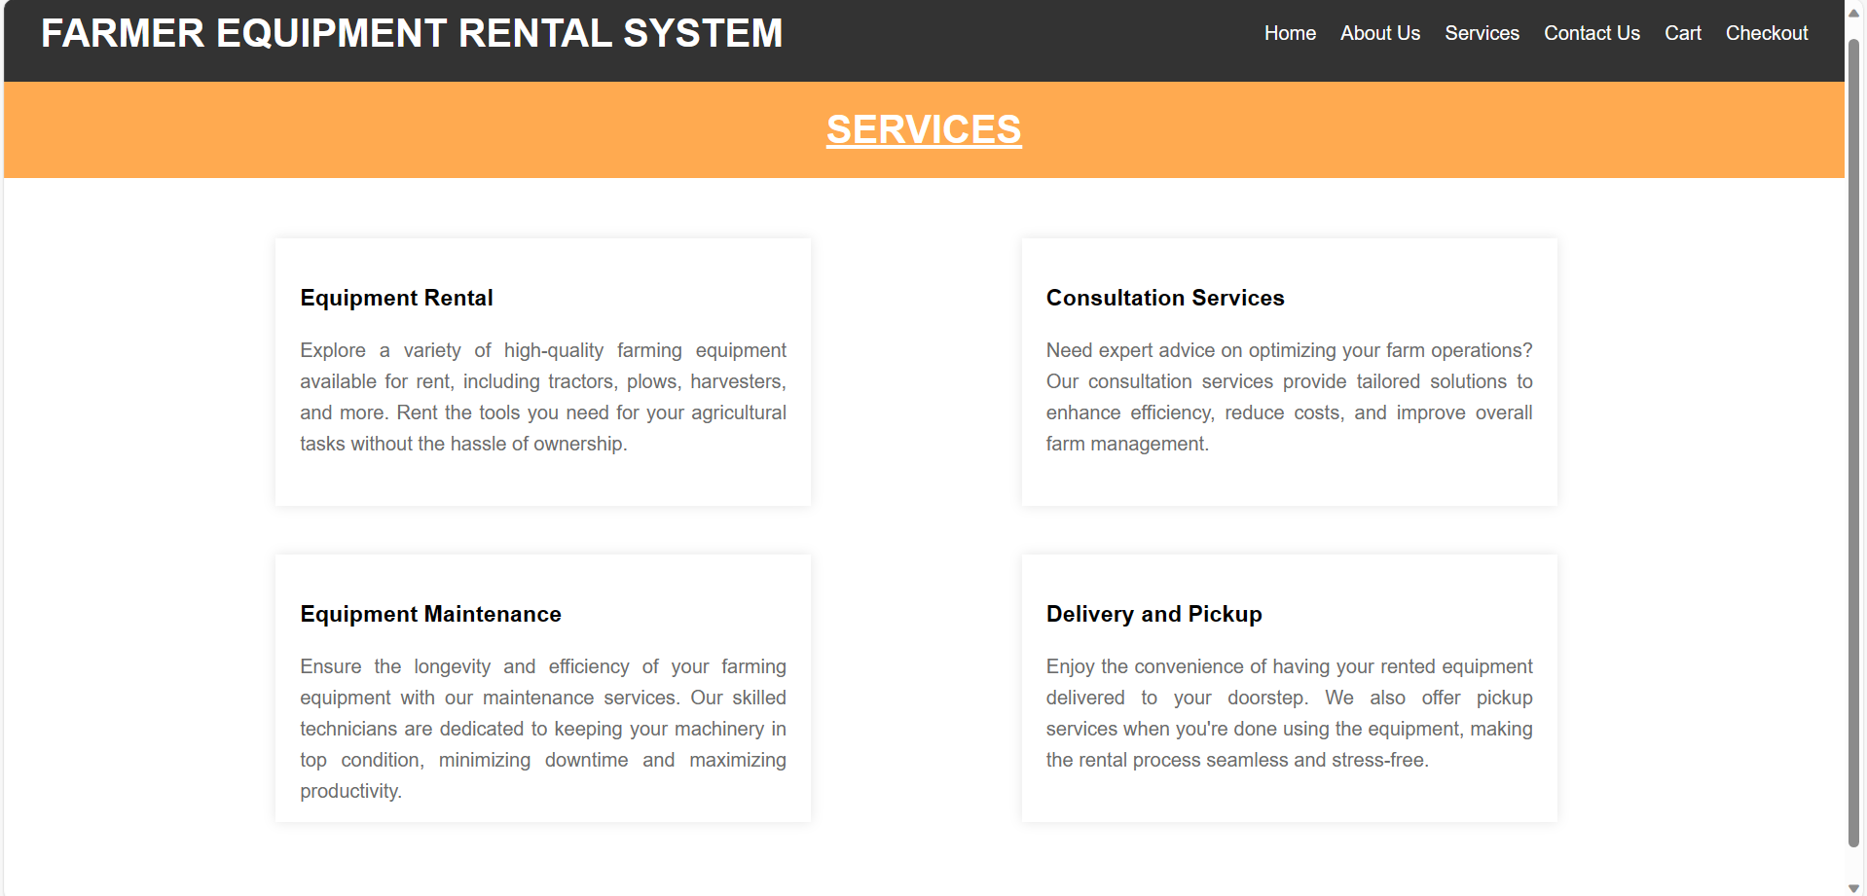

**Fig 5.4** Services Page

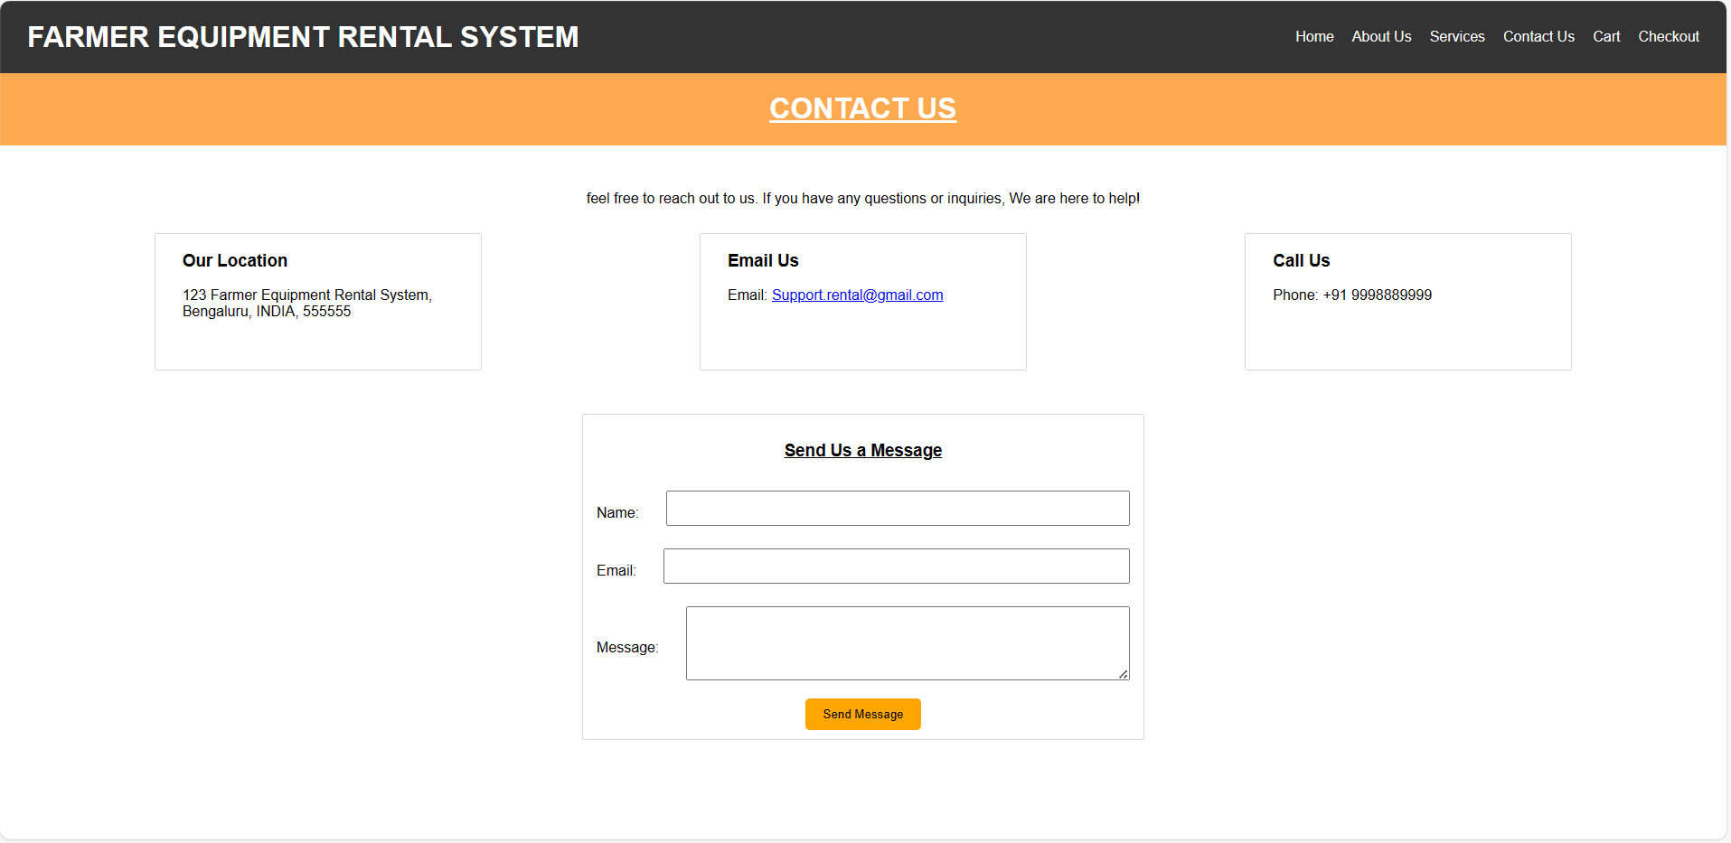

**Fig 5.5** Contact Page

**6. CONCLUSION**

Our web application transforms modern agriculture, prioritizing user-friendly functionality and technological advancements. It minimizes manual labor, enhances efficiency, and optimizes resource management. The application revitalizes farming by attracting younger generations through a tech-savvy approach, bridging generational gaps. Sustainability is a core principle, achieved through data analytics and tools for resource optimization, empowering farming communities economically. It serves as a catalyst for positive change, modernizing practices, encouraging youth participation, and ensuring a sustainable future for agriculture through the fusion of technology and tradition.

**REFERENCES**

**[1] AgroEcom: An Agricultural Equipment Rental Services for Smart Farming**

[**https://ijrpr.com/uploads/V4ISSUE6/IJRPR14553.pdf**](https://ijrpr.com/uploads/V4ISSUE6/IJRPR14553.pdf)

**[2] AGRARYANS: Farm Equipment Rental System/Based on Agriculture**

[**https://www.irjet.net/archives/V9/i6/IRJET-V9I6152.pdf**](https://www.irjet.net/archives/V9/i6/IRJET-V9I6152.pdf)

**[3] AGRICULTURE EQUIPEMENT’S RENTAL SYSTEM**

[**https://www.irjmets.com/uploadedfiles/paper/issue_3_march_2023/34591/final/fin_irjmets1679567128.pdf**](https://www.irjmets.com/uploadedfiles/paper/issue_3_march_2023/34591/final/fin_irjmets1679567128.pdf)

**[4] Agri-Equipments Rental System**

[**https://www.ijsdr.org/papers/IJSDR1905050.pdf**](https://www.ijsdr.org/papers/IJSDR1905050.pdf)

**[5] RfarmQuipment-Rental Farming Equipment Website**

[**https://www.tijer.org/papers/TIJER2304054.pdf**](https://www.tijer.org/papers/TIJER2304054.pdf)